|  |  |  |  |
| --- | --- | --- | --- |
| C:\Documents and Settings\Administrator\My Documents\Dropbox\Documents\MyDocuments\grafik\logo politeknik.png  **TUANKU SYED SIRAJUDDIN** | **DEPARTMENT OF INFORMATION TECHNOLOGY AND COMMUNICATION** | **SESSION** | 1:2021/2022 |
| **COURSE** | DFT40043  WEB DESIGN TECHNOLOGIES |
| **ASSESSMENT METHOD** | LABORATORY TASK 4 |
| **TOPIC** | 4.0 JAVASCRIPT | | |

|  |  |  |
| --- | --- | --- |
| Name : NIK DANIA ARIESYA BINTI MOHD RASHIDI | | **MARKS** |
| Reg. No : 18DDT19F1127 | Class : DDT5D | /20 |

|  |  |  |  |  |
| --- | --- | --- | --- | --- |
| **Criteria** | HTML Tags | CSS | JavaScript Indentation and Message Box | Java Script Function |
| **Marks** |  |  |  |  |

**ANSWER**

SCREENSHOT

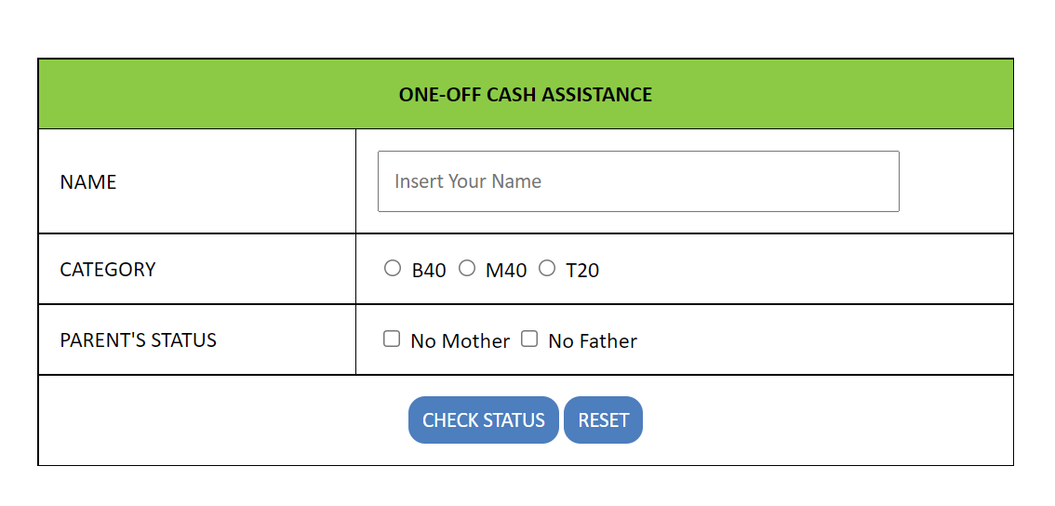

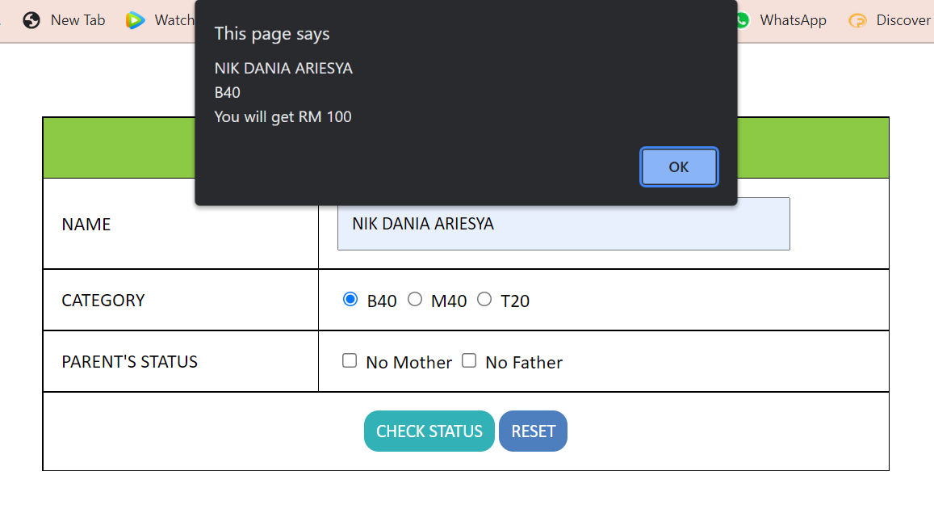

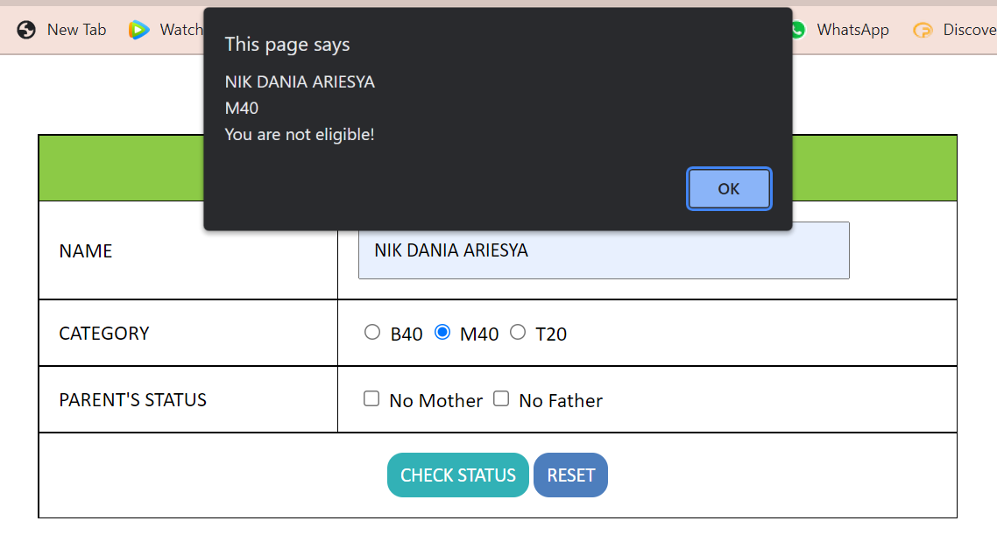

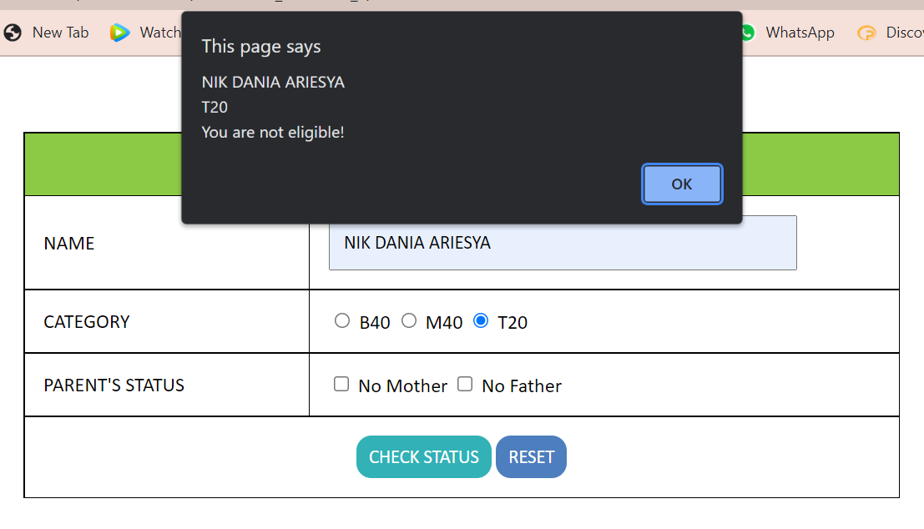

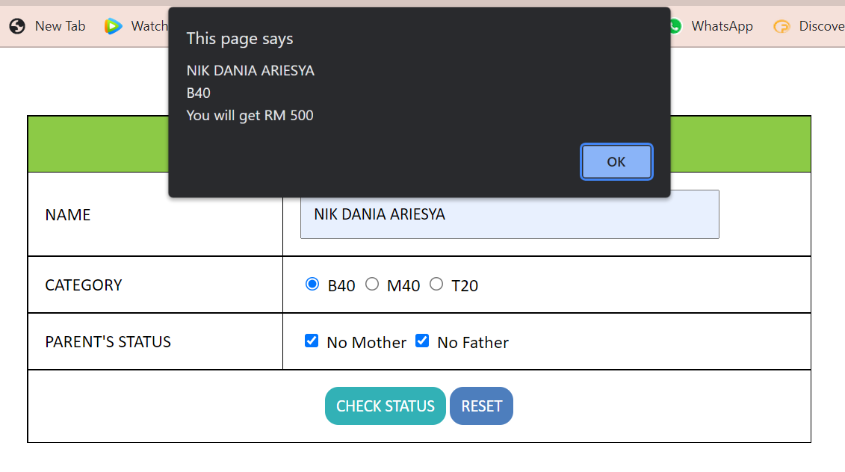

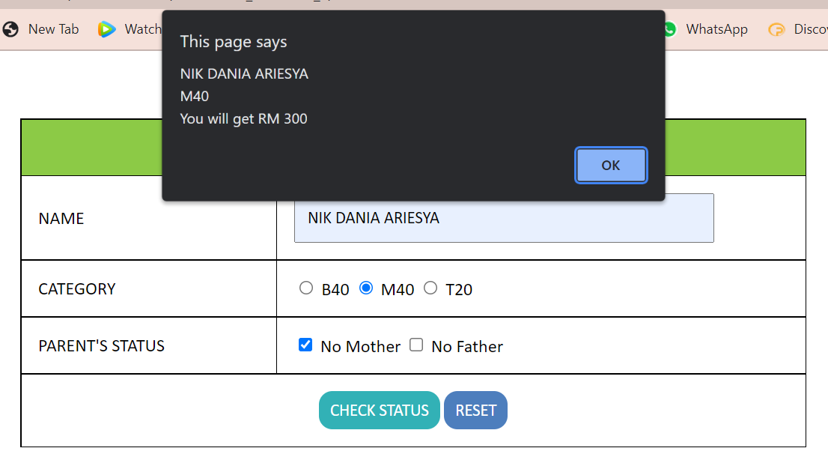

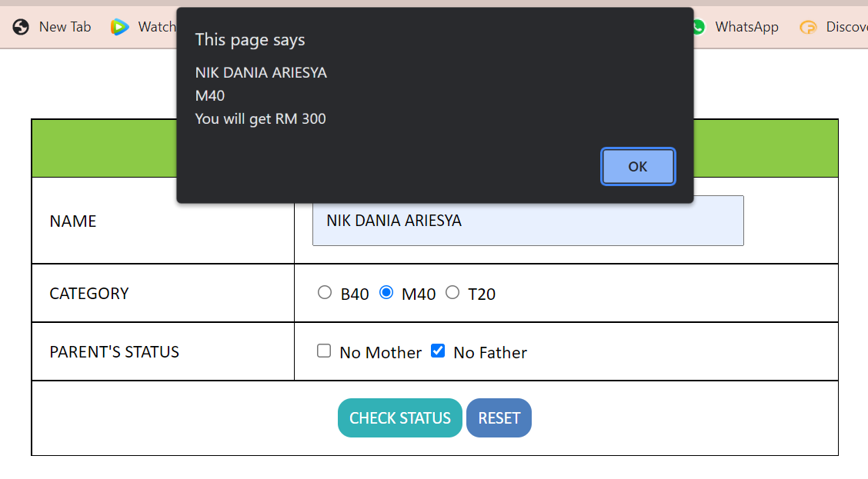

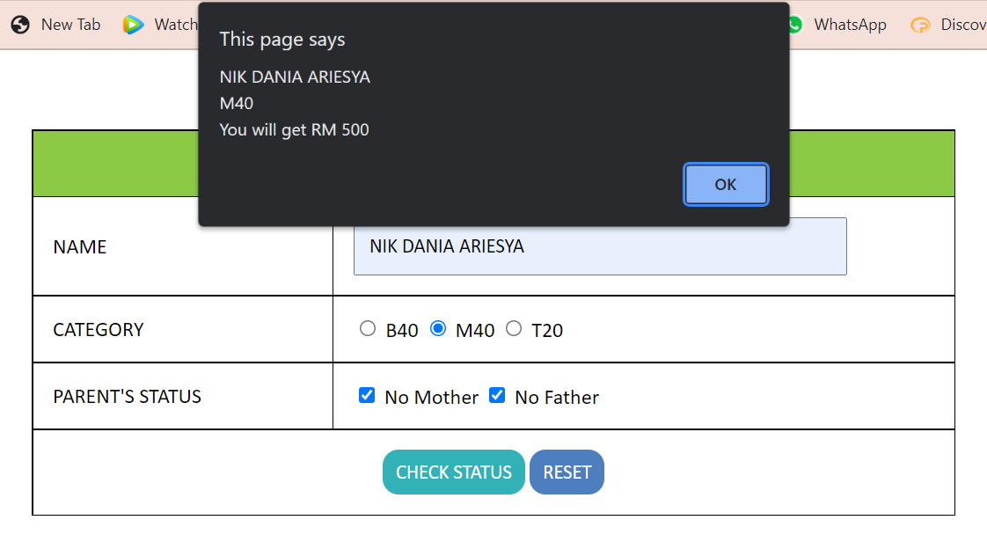

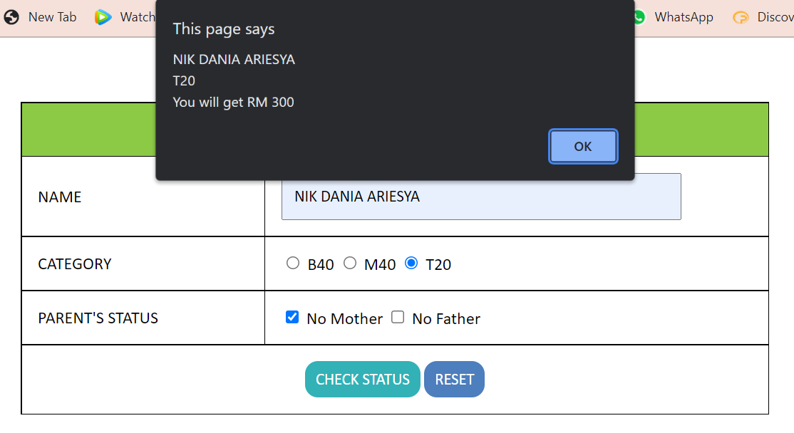

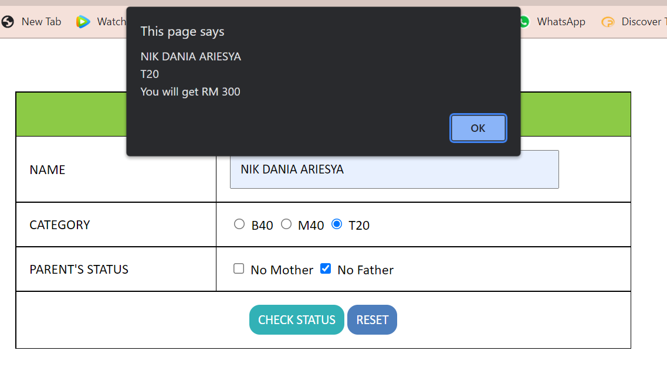

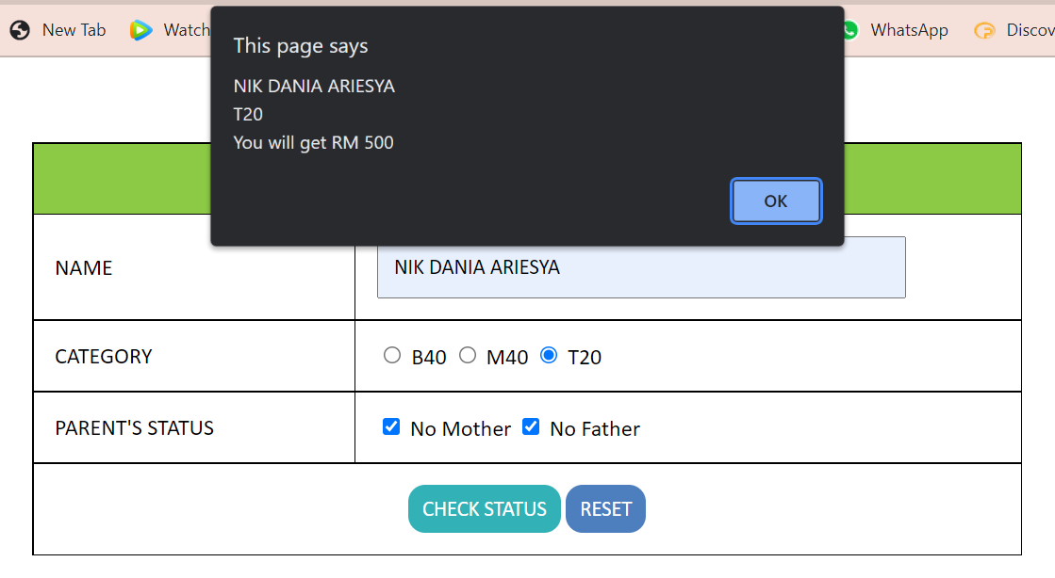

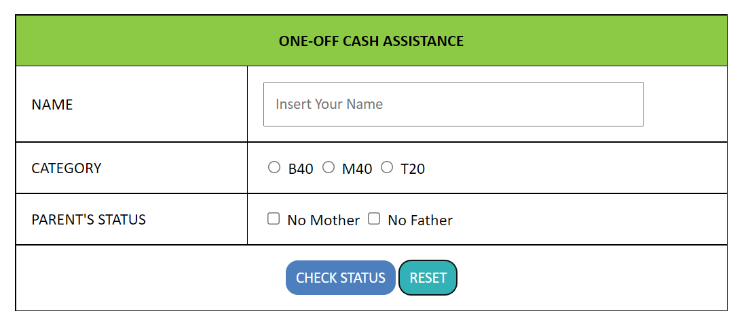

CODING (HTML)

<!DOCTYPE html>

<html lang="en">

<head>

<meta charset="UTF-8">

<meta http-equiv="X-UA-Compatible" content="IE=edge">

<meta name="viewport" content="width=device-width, initial-scale=1.0">

<title>Document</title>

<link rel="stylesheet" type="text/css" href="style.css">

<script src="status.js"></script>

</head>

<body>

<center>

<table border="1">

<form name="Myform" action="" method="post" enctype="multipart/form-data" onsubmit="return checkstatus();">

<tr>

<th class= "title" colspan="2">ONE-OFF CASH ASSISTANCE</th>

</tr>

<tr>

<td>NAME</td>

<td><input type="text" name="customername" id="name" placeholder="Insert Your Name" required>

</td>

</tr>

<tr>

<td>CATEGORY</td>

<td>

<input type="radio" id="B40" value="B40" name="category" required> B40

<input type="radio" id="M40" value="M40" name="category" required> M40

<input type="radio" id="T20" value="T20" name="category" required> T20

</td>

</tr>

<tr>

<td>PARENT'S STATUS</td>

<td> <input type="checkbox" id="Mother" value="Mother" name="Status"> No Mother

<input type="checkbox" id="Father" value="Father" name="Status"> No Father

</td>

</tr>

<th colspan="2">

<input type="submit" value="CHECK STATUS" onclick="checkstatus();">

<input type="reset" value="RESET">

</th>

</tr>

</form>

</table>

</center>

</body>

</html>

CODING (CSS)

table, th, td {

font-family: Calibri;

position: center;

border: 1px solid rgb(0, 0, 0);

width: 700px;

margin-top: 60px;

border-collapse: collapse;

}

.title {

background-color: #8cca46;

}

/*Row and Column*/

th, td {

padding: 15px;

}

/*input fill*/

input[type=text] {

font-family: Calibri;

font-size:15px;

padding:10px;

width:350px;

height: 20px ;

text-align: left;

padding-left:10px;

}

/*submit button*/

input[type=submit] {

font-family: Calibri;

border: none;

padding: 8px 10px;

border-radius: 12px;

color: #FFFFFF;

background-color: rgb(77, 126, 189);

font-size: 15px;

}

/*Reset Button*/

input[type=reset] {

font-family: Calibri;

border: none;

padding: 8px 10px;

border-radius: 12px;

color: #FFFFFF;

background-color: rgb(77, 126, 189);

font-size: 15px;

}

/*Submit hover*/

input[type=submit]:hover {

background-color: rgb(50, 177, 182);

}

/*Reset hover*/

input[type=reset]:hover {

background-color: rgb(50, 177, 182);

}

/*Form click design*/

input:focus {

background-color: #FFFFFF;

}

CODING (JAVASCRIPT)

function checkstatus() {

customername = document.getElementById("name").value;

category1 = document.getElementById("B40").value;

category2 = document.getElementById("M40").value;

category3 = document.getElementById("T20").value;

if (customername === '') {

alert('please insert your name');

} else {

//B40 Category 1

if (document.getElementById("B40").checked) {

if (document.getElementById("Mother").checked && document.getElementById("Father").checked) {//An Ophanage

alert(customername + "\n" + category1 + "\n" + "You will get RM 500");

return false;

}

if (document.getElementById("Father").checked || document.getElementById("Mother").checked) {//Single Parents

alert(customername + "\n" + category1 + "\n" + "You will get RM 300");

return false;

}

alert(customername + "\n" + category1 + "\n" + "You will get RM 100");//Both Parents

return false;

}

//M40 Category 2

else if (document.getElementById("M40").checked) {

if (document.getElementById("Mother").checked && document.getElementById("Father").checked) {//An Ophanage

alert(customername + "\n" + category2 + "\n" + "You will get RM 500");

return false;

}

if (document.getElementById("Father").checked || document.getElementById("Mother").checked) {//Single Parents

alert(customername + "\n" + category2 + "\n" + "You will get RM 300");

return false;

}

alert(customername + "\n" + category2 + "\n" + "You are not eligible!");

return false;

}

//T20 Category 3

if (document.getElementById("T20").checked) {

if (document.getElementById("Mother").checked && document.getElementById("Father").checked) {//An Ophanage

alert(customername + "\n" + category3 + "\n" + "You will get RM 500");

return false;

}

if (document.getElementById("Father").checked || document.getElementById("Mother").checked) {//Single Parents

alert(customername + "\n" + category3 + "\n" + "You will get RM 300");

return false;

}

alert(customername + "\n" + category3 + "\n" + "You are not eligible!");//Both Parents

return false;

}

else

alert("Please Complete The Form!");

return false;

}

}